**Technical Report**

**Playing Pong with TensorFlow and Keras**

**Discovery Lab – Global (DLG)**

By

Grant Guernsey

**Table of Contents**

**Introduction**……………………………………………………………………………………4

**Abstract**…………………………………………………………………………………………..5

**Installing and running Karpathy’s SmartPong Code**…………………………..…………..6

Issues Running Code……………………………………………………………………7

**Installing and Running My Code**…………………………………………………………….9

**Theory**…………………………………………….…………………………………………..10

General Machine Learning Theory……………………………………………………10

TensorFlow and Keras……………………………………...…………………………10

Convolutional Neural Network………………………………………………………..11

Filters………………………………………………………………………….13

Padding………………………………………………………………………..14

Activation……………………………………………………………………...15

Pooling………………………………………………………………………...16

Loss…………………………………………………………………...…………….…18

Optimizers…………………………………………………………………...………...19

**Breakdown Of My Code**……………………………………………………………………..24

Installing Dependencies………………………………………………………….……24

Importing Dependencies……………………………..………………………………….25

Creating The Environment………….…………………………………………………26

Preparing The Image…………………………………………………………………….27

Creating The Reward………………………………………………………………….30

Creating The Model…………………………………………………………………...32

Training The Model…………………………………………………………………...39

Plotting The Results……………………………………………………………………..55

Watch The Model Play………………………………………………………………….56

**Speed comparison of the code**…………………………………………………………………60

Speed Difference explanation…...………………………………………………………61

**Optimization Graphs**………………………………………………………...………………66

**The Process to Create My Code**…………………………………………………………….73

**References**……………………………………………………………………………………….77

**Introduction**

For this co-op, I was given Andrej Karpathy’s code, titled SmartPong. This program implements artificial intelligence to play the game of pong and learn how to win. The SmartPong code outputs lines of code that show the efficiency of the AI (Artificial Intelligence) as the number of episodes increases. Using a machine learning library, my goal was to recreate Karpathy’s code to make it more efficient.

Analyzing the Atari game of pong with Karpathy’s code, I was able to learn the foundations of Artificial Intelligence. Given the code and working backward and learning exactly what Karpathy did and why allowed me to learn the basics of an AI model that learns a game.

The first challenge that was faced was getting Karpathy’s model to run correctly. Because some of the libraries have not updated to the latest version of python, The python 3.9 compiler that I had already installed would not work. This problem was simple to solve by using an outdated python compiler that was the correct version for the libraries.

Next, I ran into countless issues creating my model to play the game of pong. I started using Stable Baselines 3 to teach artificial intelligence, but the efficiency was extremely low and would have taken multiple weeks to fully train. After Stable Baselines 3, I attempted using PyTorch and invested a lot of time into creating the program. This program eventually failed because of the complexities that I was trying to use and the more difficult syntax and code usage of PyTorch over some of the other libraries.

Lastly, I used Keras and simplified the logic I was using in PyTorch and I made a model that was much more efficient than the Karpathy’s while still keeping a short amount of code similar to Karpathy. After many trials of finding the best optimization, my Keras model ran 98% faster than Karpathy’s smart pong code.

**Abstract**

This technical document shows the logic and the processes that I took to get to my code. The documentation also includes how to install and run Karpathy’s code and the changes that need to be made to it, as well as the steps to run my code. This documentation includes the theory behind the artificial intelligence principles that I used and a line-by-line analysis of my code. This line-by-line analysis shows the reasoning behind the decision I made while creating my Artificial Intelligence.

**Installing and Running Karpathy’s Code**

1. Install Python 3.7 from <https://www.python.org/ftp/python/3.7.0/python-3.7.0-amd64.exe> and check the option to add it to PATH
2. Download and install archived anaconda version released 2019-07-05 or from this link <https://repo.anaconda.com/archive/Anaconda3-2019.07-Windows-x86_64>.
3. Download Andrev Karpathy’s SmartPong code from [https://gist.github.com/Karpathy/a4166c7fe253700972fcbc77e4ea32c5](https://gist.github.com/karpathy/a4166c7fe253700972fcbc77e4ea32c5) as a zip file
4. Extract the files from the zip file.
5. Download and install Microsoft Visual Studio from <https://visualstudio.microsoft.com/thank-you-downloading-visual-studio/?sku=Community&rel=16>
6. Download and install C++ build tools from <https://visualstudio.microsoft.com/thank-you-downloading-visual-studio/?sku=BuildTools&rel=16>
7. Download and install Git from <https://git-scm.com/download/win>
8. Open the command prompt by typing cmd into the windows search bar
9. Type “pip3 install gym NumPy” without the quotation marks, and press enter
10. Type “pip3 install git+https://github.com/Kojoley/Atari-py.git” without the quotation marks, and press enter
11. Find the SmartPong code that was extracted in step four and right-click on pg.pong.py and select edit with IDLE
12. Make the following Changes
    1. Line 3: import _pickle as pickle
    2. Line 24: grad_buffer = { k : np.zeroes_like(v) for k,v in model.items() }
    3. Line 25: rmsprop_cache = { k : np.zeroes_like(v) for k,v in model.items() }
    4. Line 43: for t in reversed(range(0,r.size)):
    5. Line 117: for k,v in model.items():
    6. Line 125: print(‘resetting env. Episode reward total was %f. running mean: %f %(reward_sum, running_reward))
    7. Line 132: print(‘ep %d: game finished, reward: %f %(episode_number,reward),” if reward == -1 else ‘!!!!!!!!’)
13. Save the file
14. Press run on the top bar, and then press “run module”
15. Press Control control+c to stop the program from running

**Issues Running Code**

In the process of running the SmartPong code by Andrej Karpathy in an up-to-date python compiler, an error was encountered. Both the gym library and the Atari library were not being properly imported into the code. The gym and Atari libraries are what create the environment that will be learned from, and without that the pong environment can not be created, therefore not allowing the pong game to play.

To figure out the problem that was occurring, the source files, as well as the usage documents, were researched. From this research, it was determined that the Atari package and the gym package were not able to run in the current version of python, which is version 3.9. To fix this issue, the source files of python 3.9 had to be deleted from the computer using Microsoft uninstaller. This was followed by researching the python archives to find a downloadable version of python 3.7, which was released in 2018. This is the most recent version of python that is supported by the Atari package.

Because all the packages had been installed under python 3.9, they needed to be installed under the new working python 3.7. To do this, the Anaconda program was used.

1. The command pip3 uninstall gym NumPy was used to uninstall the NumPy and the gym packages from the computer.
2. The command pip3 uninstall gym[Atari] was used to uninstall the Atari package.
3. The command pip3 install gym NumPy was used to reinstall the gym and NumPy packages into python 3.7.
4. The command pip3 install gym[Atari] was used to reinstall the Atari package into python 3.7.

After this procedure was followed, the SmartPong conde from Andrej Karpathy was able to run and be observed and understood.

**Installing and Running My Code**

1. Download and install Python 3.7 from <https://www.python.org/ftp/python/3.7.0/python-3.7.0-amd64.exe> and check the option to add it to PATH
2. Download and install archived anaconda version released 2019-07-05 or from this link <https://repo.anaconda.com/archive/Anaconda3-2019.07-Windows-x86_64>.
3. Download my code from <https://github.com/GrantGuernsey/Machine_Learning_Co-op/blob/main/smartpong_keras_guernsey.ipynb>and hit the button that says raw
4. Press control+s and save to your desired location, naming it smarterpong.ipynb and save as file type “All Files”
5. Launch Jupyter notebook from the windows search bar.
6. Press the upload option in Jupyter notebook and select smarterpong.ipynb from the location in which you saved it
7. Open the code and click on the block below where it says install dependencies and press shift+enter
8. Now continue box by box through my code using shift+enter to run the block
9. The Train the model block will take some time, uncomment the lines env.render() and env.close() to watch the progress of the model as it runs through 1000 episodes!

**Theory**

**General Machine Learning Theory**

Machine learning is divided into three distinct categories. Supervised, Unsupervised, and Reinforcement Learning. In supervised learning, data is fed into the model as an input, and the expected output is also fed into the data. This allows the model to come up with the most efficient algorithm to get to the desired output. In unsupervised machine learning, data is fed into the model with no expected output. Unsupervised learning can form hidden connections and patterns in data with only minimal human supervision.

In reinforcement learning, data is fed into the model, and based on the model’s decision, a reward is given. Using this reward, the model learns which actions are good and which actions are bad and the model is then able to change its parameters to attempt to get the good reward more often. Therefore, the model will lean an ideal behavior in the environment that it is set in. In the game of pong, a snapshot of the game is fed into the model, and from the snapshot, the model will choose whether it wants to move the paddle up or down. After the model wins or loses each match, it is given a reward, and in the game of pong, this reward is either -1 or 1. At the end of each episode, a set of 21 individual matches, these rewards, actions are taken, and all the snapshots of the game are fed into the model to learn.

**TensorFlow and Keras**

TensorFlow is an open-source library for deep learning that is developed and maintained by Google. TensorFlow is the backend of what is used in my code to achieve reinforcement learning. TensorFlow works by accepting all its inputs as a multidimensional array called a tensor. By definition, a tensor is an n-dimensional vector or matrix that can represent any form of data. Tensors are in both input data as well as output calculations. Tensors are the core of TensorFlow and are what allows it to achieve deep reinforcement learning.

Keras is an open-source library that runs on top of TensorFlow. It was designed to be easier to use than TensorFlow and can construct many different variations of deep learning algorithms. Keras has extensive documentation and guides created by developers that work to minimize the number of user actions required to create a deep learning algorithm.

There are a few key differences between Keras and TensorFlow. Keras is simple to use in the language of python if you already understand python. With knowledge of python, keras syntax is easy to follow and implement. With TensorFlow, the syntax is more proprietary and has more low-level API. Tensorflow can be quite difficult to use and debugging TensorFlow code is more difficult than Keras. The main benefit of Tensorflow over Keras is that TensorFlow has much higher performance on large data sets. Keras is not very efficient when the model is leaning with exceptionally large data sets.

For the models that I created, I chose to use Keras because of the ease of use. If a larger size of data was being used, I would have chosen TensorFlow, but because all of the data is the frames of the pong game, the efficiency of TensorFlow was not needed.

**Convolutional Neural Network**

A convolutional neural network is a deep learning algorithm that takes images as input. This is different than many algorithms which take in an array or a database as input. This allows for less preprocessing of data, which in the case of the game of pong allows the image to be kept as a 2d array rather than a 1d array of all of the image values.

There are a handful of distinct types of layers in convolutional neural networks. A few of these layers are convolution, pooling, and dense layers. Within each convolution layer, different variables can be tweaked to gain greater performance of the network. These variables are the kernel, stride, filter size, and padding. Each of these changes the way that the neural network works with an image.

A kernel is a matrix of weights that are multiplied by the image to extract features. The kernel moves over the input data and performs the dot product of the weights to the values of the pixels in the image. The kernel size determines how large the kernel matrix is. The larger the matrix, the less precise the features will be. The most used kernel size is a 3x3 because it allows for the most clarity in the image to be extracted. The kernel size can be tweaked based on the specific use for greater accuracy or speed.

The stride in a convolutional neural network determines by how much the kernel moves between each set of pixels. Each stride is a multiplication of the kernel matrix and the portion of the image. The most commonly used stride is 1, meaning that the kernel only moves over 1 vertical layer after each calculation. The animated image below represents a stride size of 1 with a kernel matrix of 3x3. With each vertical stride, a new value is saved into the output matrix based on the dot product calculation of the kernel matrix and the portion of the image.



The next tweakable parameter of a convolutional neural network is the filter size. The filter size determines how many kernel matrixes calculations there are in each layer. With more filters, the network is more accurate and can extract more definite features from the image quicker, but it is at the cost of the speed. The theory for convolutional neural networks dictates that the deeper into the network you go, the more filters there are. With more filters, more definite images can be seen, which leads to much greater accuracy of the algorithm. The animated image below shows a filter size of 3, or an RGB image, calculating the dot products of each stride based on the kernel size, and saving all of the sum of them plus the bis into the output image.



Another parameter of a convolutional neural network is padding. Padding is the number of pixels added to the image to process the kernel. Two common types of padding are valid and the same padding. With valid padding, if the image size is 4x4 and the kernel size is 3x3, the output will be a 2x2 matrix. With valid, the output data is downsized. With the same padding, the output data is not downsized. An additional layer of zeroes is put onto the outside of the input image so that after the kernel is passed over the entire image and all of the dot products are calculated, the output size is the same as the input size. For example, with the same padding, if the input image is a 4x4 and the kernel size is a 3x3, an extra layer of zeroes is padded onto the outside of the input image to make it into a 5x5. After the dot products are calculated, the output is a 4x4, hence why the name is the same. In the animated image below, the first image is that of valid padding, where it can be seen the shrinkage. The third image is that of the same padding.



An additional change that can be made to each convolution layer is the activation function that is used. An activation function is a node that is put at the end of or in between each of the layers of the neural network. The activation functions determine if the neuron will fire or stay dormant. The most commonly used activation functions are SoftMax, Sigmoid, tanh, ReLU (rectified linear unit), and Leaky ReLU.

SoftMax activation it is used to predict a probability distribution. This is most used in the output of the neural network because it gives a probability distribution for each of the possible actions of the network.

Sigmoid activation is also used to predict the probability because it only exists between the y values of 0 and 1. The shape of the sigmoid is sigmoidal, which is an s-shape. The function that is used to calculate is shown below.

Tanh is similar to the sigmoid activation function in its shape. The difference is that instead of all the y values being from 0 to one, all the y values are between -1 and 1. The benefit of this is that negative values will be mapped as strongly negative and positive values will be mapped as strongly positive. Also, values near 0 will be close to 0, whereas with the sigmoid function, values near 0 are close to 0.5.

ReLU or the rectified linear unit activation function is the most widely used. It is used in almost all convolutional neural networks. The range of ReLU is zero to infinity. This function has no negative values and is linear from zero to positive infinity. The benefit of ReLU is that it does not activate all of the neurons at the same time because it converts all of the negative values to zero. This makes it much more efficient.

Leaky ReLU is in the positive x as ReLU, but instead of all negative values being set to 0, the negative values are set to 0.1x. This helps with desaturating the negative region, meaning that the negative region will be more significant and be less saturated with just zeroes as it is in ReLU.

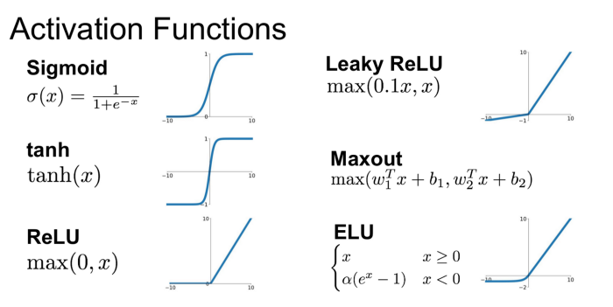

After each layer in the convolutional neural network, a pooling layer can. The purpose of a pooling layer is to reduce the overall size of the convolved features. This is done to reduce the computational power that is required to process the data and train the model. This is done through dimensional reduction using a kernel. Pooling layers are extremely useful in extracting features that are not dependent on their rotation, which maintains the accuracy gained through the training.

Pooling layers come in two different fashions, max pooling, and average pooling. Max pooling returns the maximum value over the portion of the image that is being looked at by the kernel. Average pooling returns the average value of the portion of the image that is being covered by the kernel. Max pooling is generally used over average pooling because it has a higher performance. After all, max-pooling acts as a noise suppressant by throwing out the noisy activations. This means that max-pooling is being used as a noise suppressant as well as a dimensional reduction. This is different than average pooling because average pooling only performs dimensional reduction and does not have a noise suppressant mechanism.



The final layers of a convolutional neural network are dense layers, also called fully connected layers. To use these layers, the final pooling or convolution layer is flattened instead of being in an array. This flattened vector is fully connected to a connected layer. This is done by having every value of the flattened vector having a connection with a weight to every value of the fully connected layer. This layer is connected to a SoftMax activation layer which ultimately decides the classification of the image of the entire convolutional neural network.

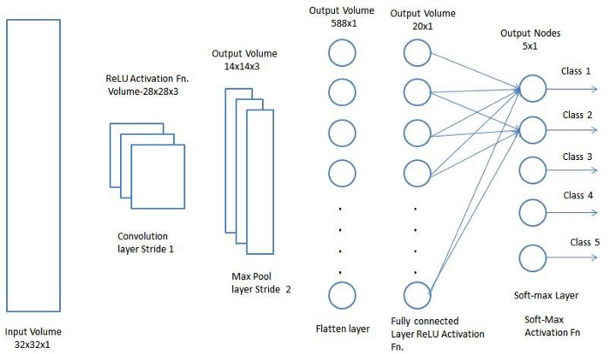

**Loss**

In a neural network, the loss is a prediction of the error of the neural network. This makes the loss function especially important. The loss is used to calculate the gradients, which are then fed into the neural network to update the weights. In Keras and TensorFlow, there are essential loss functions that are built-in. These loss functions are Mean Squared Error, Binary Crossentropy, Categorical Crossentropy, and Sparse Categorical Crossentropy.

The Mean Squared Error function is used for tasks that deal with regression. The loss function is calculated by taking the mean squared differences between the actual data and the predicted value. Mean squared error is commonly used when a neural network is used when the output is a real number.

Binary Crossentropy is used for binary classification. The output for this loss function is a range from zero to 1 which is achieved by using the sigmoid activation function. Binary Crossentropy is used when a neural network takes an input and outputs the likely hood that the is 0 or 1, more commonly used as yes or no.

Categorical Cross entropy is used for multiclass classifications, such as images. For this loss function, there must be the same number of output nodes as there are classes. The final layer output of this loss function is a probability value between 0 and 1 which is achieved by using the SoftMax activation. This means that whichever of the final nodes has the highest probability value will be activated. This loss function has to one-hot encode the target values at the time of training.

Sparse Categorical Crossentropy uses the same loss function calculation as Categorical Crossentropy. It uses the final SoftMax layer to pass a probability that ultimately chooses which activation to use. The difference between sparse and non-sparse is that for sparse there does not have to be hot encoded values passed into the function to train. For sparse, only the index must be passed into the model to train. This is used for the game of pong because of the reward system that is used for the model. Instead of having predetermined rewards, the rewards are created as the artificial intelligence runs. These rewards are then discounted and passed into the loss function.

**Optimizers**

An optimizer in deep learning is an algorithm or method that is used to minimize the loss function and maximize the efficiency of the program. Optimizers are mathematical functions that are entirely dependent on the learnable parameters of the neural network, or the weights and biases.

The most basic optimizer is gradient descent. The gradient is also known as the “slope” and represents a relationship between two variables. Gradient descent is an optimization algorithm that changes its parameters iteratively to find the local minimum of a given function. Gradient descent reduces the loss function with each generation. Gradient descent is the core of deep learning, as the more complex optimizers are still descending the gradient. The image below shows a visualization of the gradient, and the weights descending on it to find the minimum cost, or the most efficiency and accuracy.

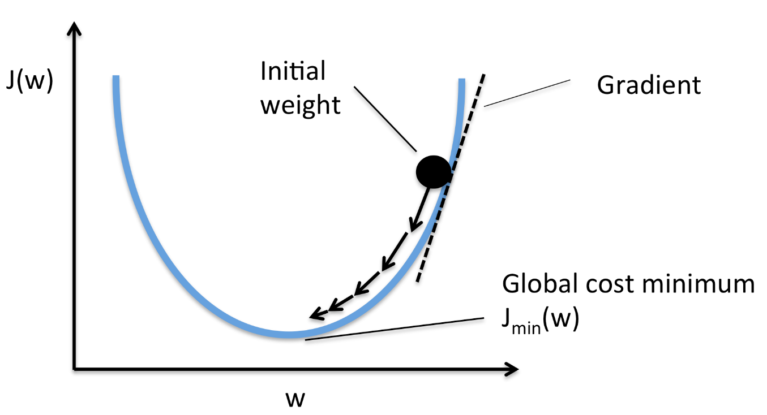

One parameter that is common across most optimizers is the learning rate. The learning rate is how large or small the steps take in the direction of the gradient towards the local minimum. This determines the speed at which the weights will converge with the minimum. If the learning rate is too low, the neural network will require many episodes to reach the local minimum. If the learning rate is too high, the weights will move around too much which can cause a diversion instead of a convergence at the minima.

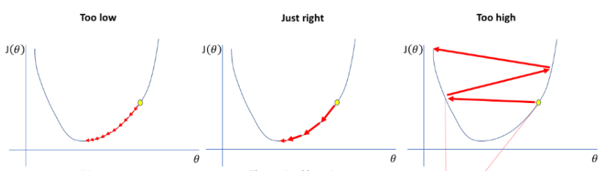

One variation of gradient descent is stochastic gradient descent. This version of gradient descent updates the parameters one by one. This means that if the model is fed a data set with 10k values, stochastic gradient descent will update the parameters of the model 10k times. This does not require much memory and is very compatible with larger data sets. The downside of using stochastic gradient descent is that it has a high variance, and the frequent updates are very computationally expensive.

Mini-Batch gradient decent combines the concepts of stochastic gradient descent and batch gradient descent, which is gradient descent, but the parameters are only updated after a batch instead of after each thing of data. Mini-Batch gradient descent is remarkably similar, splitting training data sets into small batches and performing updates at the end of each batch, but also uses the stochastic gradient descent approach of updating the parameters one by one. This creates a balance of robustness from stochastic gradient descent and the efficiency and speed of batch gradient descent. This leads to a more stable convergence on the gradient and more efficient gradient calculations. The downside is that mini-batch gradient descent does not guarantee a good convergence, just that it will converge. Also, if the learning rate is too small, the convergence will be incredibly slow, and if the learning rate is too high then the loss function oscillates and never reaches zero, meaning that it will never be accurate.

Adaptive gradient decent changes from the previous optimizers because instead of having a static learning rate, the learning rate is different for every neuron for every layer has its learning rate based on the iterations of learning that it has gone through. This learning rate is calculated by the cumulative sum of the squared gradients. This makes it efficient at training on sparse data or data that is not close to each other. The downside is that if the learning rate for a neuron becomes too small, it can cause the neuron to die and become useless in the neural network.

A popular optimizer is RMS-Prop or Root Mean Square Propagation. This is a version of adaptive gradient descent that calculates the learning rate by using the exponential average of gradients. RMS-Prop combines the concept of momentum with adaptive gradient. The largest disadvantage of RMS-Prop is that it can lead to slow learning, but it is incredibly accurate with its convergence.

AdaptiveDelta or AdaDelta is an extension of adaptive gradient that removes the decaying learning rate problem that can lead to dead neurons. In AdaDelta, there is no set learning rate and the learning rate is calculated as the ratio of the running average of the previous timesteps to the current gradient. The disadvantage of AdaDelta is that it is computationally expensive.

One of the most popular optimizers in Keras and TensorFlow is Adam or adaptive moment estimation. Adam is a method that computes an adaptive learning rate for each parameter, meaning that each parameter has its learning rate, unlike gradient descent where the entire equation has one static learning rate. Adam stores the decaying average of the past gradient and the decaying average of past squared gradients, combining the advantages of both RMS-Prop and AdaDelta. This makes it very computationally efficient, and it requires memory. Because the learning rates change for each parameter, there is no need to set a learning rate, making it quite easy to implement.



**Breakdown Of My Code**

1. **Install Dependencies**

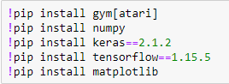

In these four lines, the dependencies or libraries that are used to run this code are downloaded. This download is done through jupyter notebook using anaconda, but if you want, it can be downloaded using the command prompt by removing the exclamation points and entering them one by one.

The first package that is installed is gym [Atari]. This gym package is a powerful package with hundreds of game environments, all of which can be used for machine learning and artificial intelligence. In this project, the Atari library is imported from the gym because the Atari game of pong is being played.

Second, the NumPy package is installed. This package allows the usage of multination arrays in python, as well as various matrices operations. This package is used in the code to create zeroes arrays, or arrays that are filled with zeroes, as well as computing the mean and taking random action.

The next two packages, Keras and TensorFlow, are used to create the neural network and the machine learning model. These two packages are downloaded as specific versions because there are more recently released versions, but those may not work with the code because some of the functions have been deprecated (may see warnings while running code about functions that have been deprecated in later versions). Keras is what is going to be used to create the model, but it will be using a backend of TensorFlow, meaning that some of the processes will be passed off to TensorFlow because TensorFlow has been very well optimized.

The last package, matplotlib, is used solely to plot the graph at the end. This package does not have to be downloaded if a graph is not needed from the code

1. **Importing Dependencies**

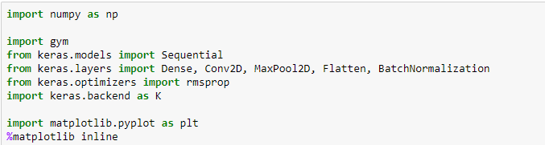

In this section of the code, all the libraries that were imported in the previous section are imported into the code here. The first line, import NumPy as np, imports the NumPy library. The NumPy section of the line makes it so that in the code, instead of having to say NumPy,function() every time it is used, instead all that has to be said is np.function(). This is extremely common while using the NumPy class.

Importing the gym class allows for the gym environment to be created. This allows the game of pong to be created and be played by machine learning. This also allows the environment to be shown on the screen as it is running.

In the next four lines, certain parts of the Keras library are imported to the code. Importing sequential is importing the way the machine learning model is going to be used in the code. The next line imports what is going to be used to configure the model and create the shape and size of the model. Importing rmsprop is an optimizer for the model to improve the speed of the learning. Importing keras.backend allows TensorFlow to be used as the backend to further improve the speed of the learning.

Lastly, matplotlib is imported into the program to graph the reward over episodes. The next line allows the graph to display within the jupyter notebook. Usually, when a graph is plotted using matplotlib, it creates a pop-up box outside of the notebook. This will allow the graph to pop up in the notebook and stay there.

1. **Creating The Environment**

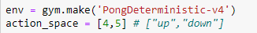

This two-line segment of code creates the observation space and the action space, also known as the environment. The action space contains all of the possible moves that can be made in this environment. By default, the Atari class has 6 actions in its action space. These actions are “NOOP”, “FIRE”, “RIGHT”, “LEFT”, “RIGHTFIRE”, “LEFTFIRE”. This can also be found by using the function get_action_meanings() in the code after the environment is created. These actions are stored as a value of 0-5 respectively in the code. For the game of pong, only two of these actions need to be used, RIGHTFIRE and LEFTFIRE. These actions control the up and down of the artificial intelligence paddle. The other four actions are not used in the game of pong but are still in the action space because other games in the gym Atari library use them.

The observation space for the pong environment is a 210x160x3 unit8 frame. This is what is shown when the function env.show() is run. The 210 represents the height of the frame in which the pong environment is created, 160 represents the width, and 3 represents the channels. In the case of the pong environment, the three channels are red, green, and blue.

Using the gym class, the “PongDeterministic-v4” environment is created and as env. There are multiple versions of the Pong game in the gym class, but I found that PongDeterministic-v4 worked the best for this model. The reason that it works the best is that it skips four frames every time. In the non-deterministic version of the game, a frameskip is sampled from two to five. It is theorized in a paper written by Adil Kahn called “Optimal Skipping Rates: Training Agents with Fine-Grained Control Using Deep Reinforcement Learning” that the perfect balance between speed and final performance is skipping frames in the range of three to eleven frames. The difference between PongDeterminstic-v4 and v0 is that with v0, there is a 25% probability that the previous action will be taken instead of the newly calculated action. The v4 version makes that probability 0, which I have found to make the model run more accurately.

In the second line, action space is set equal to [4,5] or RIGHTFIRE and LEFTFIRE. Instead of using the action space that is already contained in the gym environment, an action space just containing the values that will move the model is created. This is done because it will simplify accessing the action space to get the action that we want the machine learning model to make.

1. **Preparing The Image**

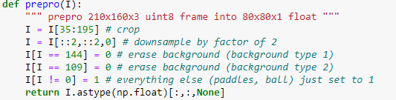

The image preprocessing in my code is remarkably similar to that in Karpathy’s code. This preprocessing of the image breaks down the image to only the components that will affect the actions that the model will take. This allows the scoreboard and the borders to be removed, as well as all of the colors in the frame. Preprocessing the image will allow the model to only see the necessary components, therefore increasing the rate at which it will learn to play the game.

The image created by the gym environment is a 210x160x3 image. This means that the image. The 210 represents the height of the frame in which the pong environment is created, 160 represents the width, and 3 represents the channels. In the case of the pong environment, the three channels are red, green, and blue. Because the frame is in unit8, each value inside of the array is a value between 0 and 255 meaning that there are 256 possible values for each index in the array.

On the second line of code, the frame is cropped down from having a height of 210 to a height of 160. To do this only rows 35 down to row 195 are kept. This is done to cut out the scoreboard and the top border, as well as the lower border. This makes the image a 160x160 frame.

Downsampling an image reduces the complexity of the image which will make it easier for the artificial intelligence to learn. This downsampling is done by removing every other row and every other column of the frame. The first value in the line of I[::2,::2,0] is ::2, which uses the python syntax start:stop:step. There is no start or stop in ::2, so the entire array is indexed and skips every second row starting from the first row and going to the last row. The last part of the line of “0” removes the red and green channels, leaving just the blue channel. This line updates the image from a 160x160x3 to an 80x80x1 frame.

The lines I[ I=144] and I[I==109] = 0 erase the two background colors of the image. This sets the values of 144 and 109, which are the blue channel values of the image, and sets them to 0, which is black. This is done so that in the next line, we can make both the paddles and ball stand independently from the background. Now that the background is set to zero, the only non-zero values are that of the paddles and the ball. These values are set to one in the line I[ I != 0] = 1. This makes the balls and the paddle white.

The return line of this function returns the array I, or our now preprocessed image, as a 2d array of floats. All of the floats in this array will either be 0.0 or 1.0 because of the preprocessing steps that were run through. [:,:,None] cuts the channels since they are no longer needed, and returns all of the values in the first two dimensions of the array.

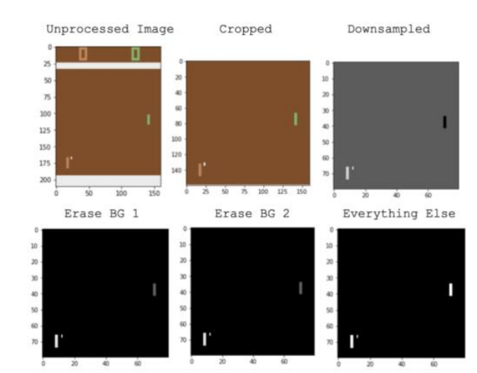

1. **Creating The Reward**

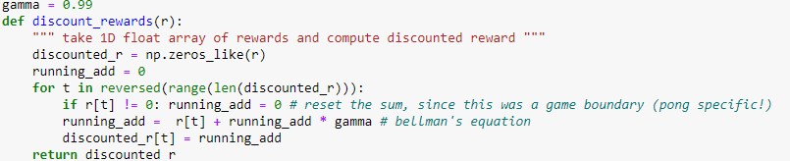

The reward system for this Artificial Intelligence is based on the Markov Decision Process (MDP). This assumes that the effects of an action taken in a state depend only on that state and not the prior history. What that means in the game of pong is that the results from the previous game, whether that be a win or a loss, do not affect any part of the next game. The ball’s starting location, speed, or any variable of such does not change based on the previous history, only that of the current game. In other words, function action is only dependent on the present.

For the game of pong, a reward is given when each game is complete. This reward is either -1.0 or 1.0. -1.0 is given when the artificial intelligence loses the match, 1.0 for when a match is won. The reward is only given when the match ends, but we do not want the model to just get the reward for when it won or lost the match. We want the actions previous to the win or the loss to be rewarded as well because those actions are what led the artificial intelligence to win or lose the game, not just the action that it made as it won or lost. That is why we used a discounted reward, using a decay rate.

Gamma is the decay rate of the reward function. In the code, we start with the variable gamma which is set equal to 0.99. This determines how quickly the reward of the action decays. This means that each value will be 0.99 of the value after it. To create this decaying reward, also known as the discounted reward, we use the function discounted_rewards. This function has the input of a 1d float array of rewards.

To create the discounted rewards, an array of zeroes is created and named discounted_r. To do this, the NumPy function of zeros_like is used. This created an array of the same dimension and size of the array that is fed into it, in this case, r, that is filled with zeroes. Then running_add is set to zero, clearing it of any previous running_add.

Next, a loop is initialized. This loop iterates through the length of discounted_r, which is the same length of r, our rewards array. This length is reversed so that we travel from the highest value to the lowest because we want to give a reward to the previous actions, not the future actions. Each iteration of the loop will have the value of t, which will start as the length of discounted_r, and then go down by one time each time through the loop.

Because the game of pong has non-zero rewards when the game ends, we want to stop creating the discounted reward for the current win or loss when another 0 is reached. This is done in the statement if r[t] != 0: running_add==0 by resetting the running_add back to 0 when r[t] is not 0, or in this case -1.0 or 1.0. r[t] is the array we take as input of the rewards.

The next line is the Bellman equation, which gives a value of reward given from a particular state. This tells us the immediate reward at a point in time. This is done by multiplying the running_add by gamma or the reward of the previous frame by the rate of decay. Then is this added to the reward at the point in the reward array. The last line in the loop saves the running add to the discounted_r array, which is what is holds our now discounted reward.

An example of this code is having a rewards array with the values [0,0,0,1,0,1,0,0,1,0]. First the discounted_r array will be created and running_add will be set to 0. Then the loop is initialized, with t starting at 9. The first time through the loop, the value of r[t] = 0, running_add=0 and will save 0 into discounted_r. The next line will have r[t] = 1, running add = [0] and after bellman’s equation, 1 will be saved into discounted reward. The next line will have r[t] = 0, running_add = 1, and after bellman’s equation, 0.99 will be saved into discounted reward. After all of the code is ran, the discounted reward array will be [0. .96059601, 0.970299, 0.9801, 0.99, 1.0, 0.99, 1.0, 0.9801, 0.99, 1, 0].

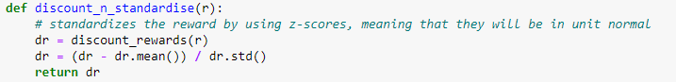

The last part of creating the reward is standardizing the rewards. This is done to make the rewards larger the farther that they are from the mean, and smaller the closer they are to the mean. That means that when a bad action is performed, it is penalized much more, and vice versa for the positive action. In this code, it is done by making each of the values a z-score.

The first line of code inside this function sets dr to the discount_rewards of r, which is the array of rewards. This uses the discounted rewards discussed previously. Then all of the values are subtracted by the mean of the array and divided by the standard deviation. This is the formula for creating a z-score. Lastly, this new standardized reward is returned.

1. **Creating The Model**

The models that I used for my artificial intelligence are all based on convolutional neural networks. Convolutional neural networks take images as the input, or as a matrix. The input shape for all my models is 80,80,1 which is the size of the preprocessed frame. In Keras, there are two types of models. There are sequential models and functional models. For this code a sequential model is used because there is only one input tensor and one output tensor, meaning that it takes one image as an input and returns one probability as the output.

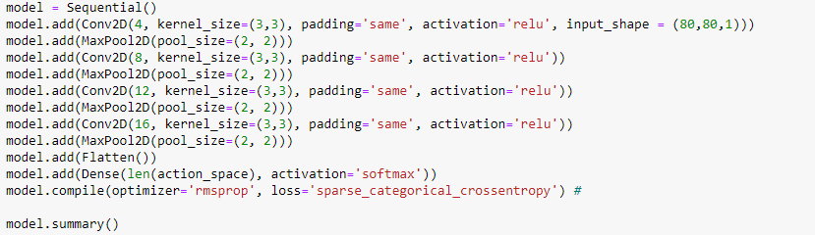

The first line of the first model is creating the model as sequential. This instantiates the model and allows layers to be added to it. The first layer of the model is a Conv2D layer, which is a two-dimensional convolution layer. To add this layer to the model, model.add is used, and to choose the type of layer, Conv2D is used. The first value that is inside of the Conv2d layer is 4, which is the filter size of this layer. A filter is the dimension of the output shape. Next is the kernel size, which through all of the models is (3,3). This specifies the size of the convolution window, in our case with a 3 height and width. Next is padding, which for this model same is used. Using the same allows the output shape to have the same dimensions as the input by padding the output with zeroes. Next, the activation type of ReLU is used. Using ReLU activation means that all values will be positive, and if a value is negative, it will be set to 0. Lastly, the input shape is defined. Since the preprocessed frame has an input size of 80x80 and one channel, the input shape is (80,80,1). This layer gives the final output shape of (80,80,4). The 80x80 is for the input size and the 4 is the number of filters that there are for this layer.

The next layer that is added to the model is a max-pooling layer. The max-pooling 2d layer goes through and gets the max value in a certain amount of space and shrinks the output shape to only the max values found in that matrix. In this model, the pooling size is (2,2) meaning that it goes over the output shape from the previous layer, gets the maximum values in a 2x2 space, and saves them into a new matrix. This changes the output shape from an 80,80,4 from the previous layer to a 40,40,4. This pooling leads to a faster training time and a reduced number of trainable variables in later layers.

The next six layers follow the same process as the first two. There are convolutional 2d layers followed by max-pooling 2d layers. The only change between each layer is the change in the filter size. Each additional convolution layer adds four more filters than the previous layer. This is done because a filter is used to find a certain characteristic of an image, and as the model moves forward, those characteristics should become less and less abstract, which means that there are more possibilities, hence why there is a progressing number of layers in this mode.

After all of the convolution layers and pooling layers are created, the model is flattened. Instead of the model having 3 dimensions, it is flattened to one dimension. So instead of the model being a 3-dimensional matrix, it is a one-dimensional vector. This is done so it can be matched with the output layer, which in the case of the game of pong is 2, the actions up to and down.

After the model is flattened, the layer that will contain the outputs of the network is created. This is done using the dense layer. The dense layer connects all of the dense nodes to all of the weights of the previous layers. This is then used to predict the output. This is done by having the size of the dense layer equal the length of our action space, which is two, and using SoftMax activation. The SoftMax activation is used because it represents a probability distribution with, in our case, two possible values. This means that the model returns the probability, from a probabilistic distribution, for each value which allows us to choose which action is desired.

Finally, the model is compiled by using the model.compile. First, the optimizer is chosen, which for this model is rmsprop. The optimizer is an algorithm that is used to minimize the loss function and to increase efficiency. Next, the loss function is defined which is sparse categorical cross-entropy for this model. Loss is the penalty that is given to the model for a bad prediction. This is used to see how well a specific model evaluates the data.

Lastly, the summary function is called for the model. This function prints out an image of what the layers, output shapes, and parameters look like. This allows for simple visualization of the neural network that was just created. It tells us how many parameters there are in total as well as how many of those parameters are changeable. Below is the output that is given when model.summary() is run.

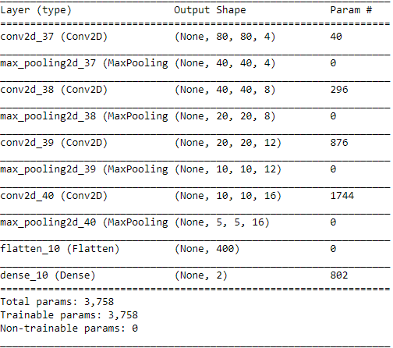

After creating this model, research was done to see if there was a similar neural network that could have better results. Using a paper written by Aidran Rosebrock called *Keras Conv2D and Convolution Layers,* a similar model was found that had similar, and in some tests more accurate learning. This paper discussed that using a power of two seems to be the most effective and that much testing is required to find the correct filter size. Kernel size was also discussed to be most effectively 3x3 or 1x1 for an image with a size smaller than 128x128. Since the input size of this model is 80x80, a 3x3 or a 1x1 kernel size should be used.

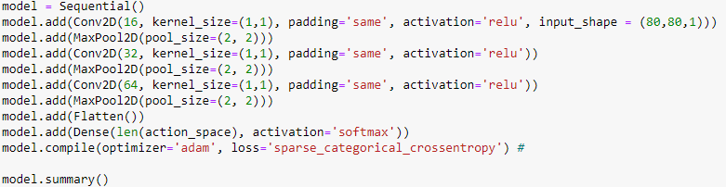

Creating this model was remarkably similar to creating the last. The model is first created as a sequential model because it is simple to use, and there is only one input and one output for this model. If multiple inputs or outputs were needed from the model, a functional API would have been chosen. After the model is declared as sequential, the layers are built.

The first layer of this model is the Conv2D layer, with a filter size of 16. The kernel size chosen for this model is a 1x1 over a 3x3 because through extensive testing of both 1x1 and 3x3 models, I found that a 1x1 was much more effective with this network. Next, the padding is set to the same meaning that it will pad each layer with zeroes to keep a consistent size across the model. This is done for clarity to the model size as well as having more space for the kernel to process the image. Next, the activation for this layer of the model is set to Rectified Linear Unit, also known as ReLU. This is done to eliminate the negative values by making them zero, and allowing all of the positive values to stay the same. Lastly, this layer has an input shape of 80x80x1 because the size of the preprocessed image that is going to be passed into the model is 80x80x1.

The next layer that is added to the model is a max-pooling layer. The max-pooling 2d layer goes through and gets the max value in a certain amount of space and shrinks the output shape to only the max values found in that matrix. In this model, the pooling size is (2,2), just like the previous model. This means that that it goes over the output shape from the previous layer, gets the maximum values in a 2x2 space, and saves them into a new matrix.

This model then differs more from the previous model by only having four layers after the initial layer. The first model had four convolution layers and four pooling layers, whereas this model only has three convolution layers and three pooling layers. This decision was made based on a neural network that was created and exampled in Rosenbrock’s paper.

The only change in the next two convolution layers is the filter size. Using the logic that each layer should be larger than the last, and the knowledge from the paper that each layer should be a power of two, the filter sizes for the second and third layer are 32 and 64 respectively. Choosing the filter sizes, including the first layer, was a matter of trial and error on the game of pong.

The next layer after the final pooling layer is a flatten layer, just like the previous model. Following this flatten layer is the same dense layer as the previous model, using the action space of two to show the number of outputs wanted, as well as using the SoftMax activation to get a probability for each move.

Another difference between the two models is found when compiling the model. Instead of using the optimizer of rmsprop, the optimizer Adam was used. This optimizer is much more widely used than rmsprop and I found it to work just as well, if not better with this model as well as with the previous model. The loss function for this model is also sparse categorical cross-entropy. Lastly, the model summary is printed out, which is shown in the image below.

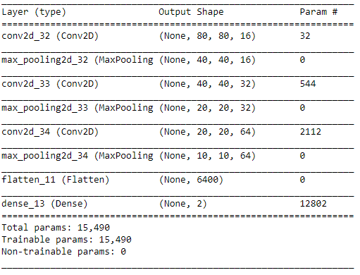

1. **Training The Model**

For the model to learn from the game of pong, it has to be trained based on the results of it running through an episode. In my code, this is done through a training loop that goes on for a specified amount of episodes.

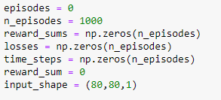

The first variable that is set is the episodes variable. This variable keeps track of what episode that the model is on. An episode is one match of pong or each time the number of wins equals 21 for either the model or the opponent. Because the training loop hasn’t run yet, the variable episodes are set to zero.

The second variable in the model training is n_episodes which is set to 100. N_episodes is the number of episodes that will be completed in training the model. This number can be changed to allow for more time training or less time training. Through testing with my model, I found 1000 episodes to have the best results. 1500 episodes, 1250 episodes, and 800 episodes were also tested in the running of this code.

The next three lines of this code are creating three arrays that will be used to save some of the data from the code. These arrays are all filled with zeroes using the NumPy function “zeroes” and are the size of the number of episodes of the training loop. This is done because each time through the training loop, one value is saved meaning that the arrays only must be the size of the number of episodes. The reward_sums array saves the sum of the reward after each iteration of the loop. The losses array saves the loss after each episode for the fitting of the model. Time_steps save how many time steps were taken before the end of the game. All three of these variables are saved to graph and see the progress that the model is making throughout its training.

The variable reward_sum is what is saved into the reward sums array. Each episode in the training, this variable will hold the sum of the rewards through the episodes, will be a value from -21 to 21 based on how many times the model won.

The input shape is declared based on the preprocessing of the image. This is done with the input_shape variable, and it is set to (80,80,1), which is the size of the image after it is preprocessed. This is done because the input shape is used multiple times through the code, and as it does not change it is easier to declare here and use the variable later. This also makes it incredibly simple to change the input_shape depending on the image input if different testing wanted to be done with the preprocessing loop.

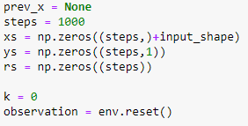

This segment of code begins by setting the variable prev_x to none. In the training g of the code, prev_x is where the previous frame of the game will be saved. This is done so there can be a comparison of the current frame to the previous frame. Prev_x is set to none because the game has not generated any frames of the gameplay yet.

The next variable that is set is steps. Steps control how many time steps will be allowed in this training. A time step is each step in the environment or each frame. Lowering the steps increases the training time, but also decreases the accuracy of the model. 1000 timesteps were the lowest that was attempted, but up to 3000-time steps were tested. 1000 timesteps were able to make enough progress to win more than most of the games, but for maximum winning potential, 2500 timesteps are the best.

The next three lines of the code are declared arrays that will be used in the training of the model. The first array that is declared is xs. Xs will save each of the differences of frames from each time through the episode. This allows these frames to be fed into the model to be trained. This array is filled with zeroes using NumPy with the shape being of step length, and the size of the input shape. That means that in this array, each value will be the size of the input shape and there can be as many values in the array as there are steps.

The second array is ys. Ys is where all of the actions that are determined from the model are saved. This is set to the size of steps and filled with zeroes. The third and last array is rs which saves the reward for each episode. This reward is also fed into the model to help it learn.

The next variable is k which keeps track of the number of steps in each episode. This is initially set to 0 because no timesteps have been completed yet. Lastly, the variable of observation is set to env.reset(). The observation variable is the observation state of the neural network. Env.reset() is the way to reset the environment in a gym library, and the output is the first frame of the game. This frame is saved into the observation that it can be used to play the game and start training the model.

Next, the training loop is created. All of the code following this, excluding the last line of the training, is contained inside this loop.

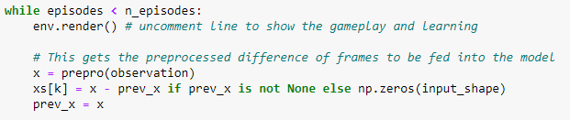

To create the loop, the line while episodes < n_episodes: is created. Episodes are the current episode that the training is on, which starts at 0, and n_episodes is the number of episodes that the training is limited to. In the case of this code, n_episodes are declared as 1000 so this loop will run 1000 times.

The line env.render() is what can render the pong game onto the computer as the neural network is training. This does take some of the computational power, so for maximum efficiency, it should be turned off. With it turned on, it allows the game to be seen as the network trains so visualization of the connections that the network is making to win the games can be seen. At first, the network will win a match or two in each episode from the randomness and will eventually learn from that and start winning in unusual ways. Sometimes, the ball will be tracked the entire time, and sometimes the paddle will rest in one spot and move to the ball right when it needs to hit it. These changes with each neural network and using env.render() allow for easy visualization,

The next line is x=prepro(observation). This line of code uses the current frame of the game, observation, and passes it into the preprocessing function. This preprocessed frame is then saved as the variable x.

The next line of code is how the difference of frames is calculated. This is done by subtracting the current frame, x, from the previous frame, prev_x. This line also has an if statement built into it that stops an error from occurring during the first frame of the episode. This is done by saying if prev_x is not none, then the difference of frames calculation is run, else np.zeroes(input_shape) is the result. This means that if prev_x is none, which it is set to before the training loop and after the end of each episode, an array of zeroes will be the image that is saved, and if it is not that first episode, then the difference of the frames is saved. These differences of frames are fed into the array xs in position k which is the timestep in the current episode. This array will be fed into the model later to train. Lastly, prev_x is set to x since all of the calculations that were needed with this episode’s x have been completed.

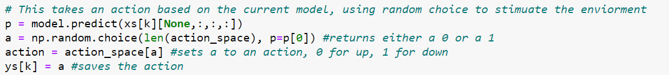

This segment of code deals with finding the action. The first line of this code segment uses the model to get a prediction using the Keras predict function. This function takes an input of a NumPy array as an input and outputs a prediction. For the input samples, the array of difference of frames is given, and because the first convolution layer wants four dimensions, the array has a fourth dimension of none added using [None,:,:,:]. This allows the data to be fed into the convolutional neural network and to get the output. The values from this are then saved as the variable p.

The next line of code uses random choice to stimulate the environment by using the NumPy function random choice. The first input that is given to this function is the length of the action space. This is in the random choice method which is what the random sample will be generated from. In this case, the length of action_space is two so the randomly generated sample will be generated from two. The second value that is given into the NumPy function is p which is the prediction value that is output by the model in the previous line. This will output a value of zero or one because of the length of the action_space. This is done because to train the model a value from zero to one is needed, but if this was not the case, then the array action_space could be used. This would output the value of four or five. These are the actions of going up and down.

Because the value that is output from the random choice method is either zero or one and the actions in the game of pong to move up and down are four and five. For this value to be changed the action_space variable is accessed and the value of up or down is chosen by using the value of the previous line. If the value of a is zero, the action will be four, and if the value is is one, the action will be five.

The last line of the action segment of the code is saving the action to the array ys. This is done in the same way that the difference of frames is saved into xs, by using the timestep value of k. This is done so that the action can be fed into the neural network with the difference of frames to let the neural network learn.

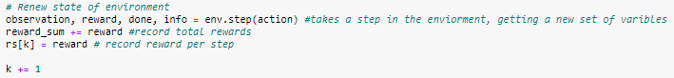

In this segment of code, the gym Atari environment is being run. In this first line of code, env.step() is executed with the parameter of the action. Env.step() is stepping in the environment; meaning is one frame of the game, and one action step of the pong paddle is completed. The parameter of action is the move that the AI paddle is going to take in this time step of the environment. This was calculated in the previous segment of the code.

The variables that are output from taking a step in the environment are observation, reward, done, and info. The observation is the next frame of the pong game after the action is taken in the environment. This will then be used in the next iteration of the loop to get the difference of frames. The reward is the reward that is gotten from that episode, which can be a negative one, a zero, or a one. If the AI loses on that turn, the reward is a negative one, if the AI doesn’t lose or win and is playing the game, the reward is zero, and if the ai wins the reward is one. The next output of env.step() is done which is a Boolean value, meaning true or false. If the pong game does not reach 21 wins on either side, then done will be false, and when the pong game is over and one of the sides has a score of one, done will be true. Lastly, info is gotten from the action step. This is a diagnostic that can be useful for debugging. This will not be used anywhere in the code.

In the second line of this segment, the reward sum is calculated. This is done by adding each of the rewards to the reward sum, getting the total rewards from the entire episode. This is done to keep track of the rewards over each episode and will be used to plot the progress of the neural network at the end of the code.

The next line in this segment of code is having the rewards from each step into the rs array using k as the index. Saving the reward into rs is going to allow all of the rewards to be fed into the neural network to learn. This is the final piece that will be fed into the model, including xs and ys.

The last line of this segment of code is incrementing the k value by one. This is done to represent that this frame or timestep of the game has been completed and is ready to be continued. If this value reaches steps, or if the Boolean value stored in done equals true, the conditional statement will be run. In this conditional statement, the data preparation is performed, and the model is trained, and the loss is found. The conditional statement is where machine learning happens.



Here, the conditional statement is being created. The purpose of this conditional statement is to fit the model and have the machine learn. This is done by the conditional statement only running at the end of each episode or when the time steps that were decided at the beginning are hit. This approach of machine learning trains at the end of each episode instead of after each timestep. This conditional statement limits the interaction the neural network can have to train.

To only train at the end of each episode, the Boolean value of done is used from the outputs of the gym environment. The value k is also used which is the number of time steps the game is currently on in this episode. If the game is done or the amount of timesteps reaches the limit that was set before the training loop, the neural network will stop playing the game of pong and learn from the previous episode.

After the conditional statement, the reward_sum is saved into the reward_sums array and then the reward_sum is reset to 0. This saves the score from the current episode and then clears it so it can be calculated in the next iteration of the game. This is used to see the progress of the neural network and see how much it is learning from episode to episode.

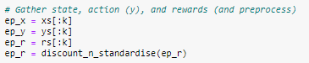

In this segment of code the observation, action, and reward are filtered down to be given to the neural network. Because of the approach taken to save these variables, there may be values inside of the arrays that are from previous episodes. This is because the xs, ys, and rs arrays are not cleared between each episode. This is to save memory in having to recreate the arrays after each episode and to save computing power. Because the arrays are not cleared between episodes, if the current episode takes fewer timesteps, meaning it has a lower k value, than the previous episodes, the values after the index of k are not important because they are from the previous episode. Also, at the beginning of training, these arrays were created by filling them with zeroes with the size of steps, which is the maximum value for k. Before k reaches that maximum value, there will be zeroes that are inside the arrays that are not from the episode, therefore need to be cut out.

To eliminate the values from the previous episode, these arrays are saved into new arrays. These arrays will be the observation, action, and reward from the current episode. These variables are named ep_x, for xs, ep_y, for ys, and ep_r, for rs. To trim the unnecessary values, the array is sliced. Slicing is a way to extract a part of an array. The syntax for slicing an array is [start:stop] or [start:stop:step], with start being the first value index that is wanted and stop being the last index that is wanted and step is the step size, default is set to one. Because the start value that is wanted to trim the array is the first index, nothing has to be set to start. For the stop value, k is used because that is the length of the episode that the data that is needed for the training. So, to get ep_x, it is set equal to xs[:k]. The same process is then repeated for ep_y and ep_r.

Once the rewards array is trimmed down to the proper length of the episode, it can be discounted and standardized. To do this, the ep_r array is passed into the discount_n_standardise function. This function discounts the rewards of the episode using a decay rate of 0.99 and then standardizes it using a z score, to make it unit normal.



The Keras method fit trains the model for a fixed number of epochs or iterations on a dataset. This training is what leads the model to learn and improve over each generation. When the model was created in the code, it was given the name model for simplification purposes.

The fit method has a total of 19 different arguments that can be used to customize the training of the mode, but for my code, only six of these arguments were used. The first argument that was used is x. X is the input data from the code, which can be a NumPy array, list of arrays, tensor, or a TensorFlow dataset. The input that was given in this instance was a two-dimensional NumPy array, which is the difference of frames in pong, which was saved as ep_x.

The second argument that is used is y. Y has to be constant in structure with the input data. Y is the target data for the code, but because this is a reinforcement learning problem, the approach is a little bit different. The target is to have the correct moves, but those are not known precisely, but to learn those actions have to be fed into the model. All the actions from each episode are saved in ep_y, so those are fed into the model.

The substantial difference with this approach is that the rewards from each episode also have to be pass4ed into the model so the model knows when it is doing well or it is doing poorly. This is done by passing the rewards in as sample weights. Sample weights are an optional array of weights for the training samples, which is used for weighing the loss function in training. In this code, the sample weight is a one-dimensional NumPy array with the same length as the input samples. The rewards array from the current episode, ep_r, is used as the sample weights. Using these sample weights mean that each of the inputs is directly connected to the sample weights. This allows the neural network to learn which moves are good and which are bad based on the reward that is being used as the weight.

The next argument is batch size. The input for batch size has to be zero, and if unspecified it defaults to a batch size of 32. The batch size is the number of samples per gradient update, meaning the number of changes that are made to the sample with each update. The value that was found to be the most efficient with this environment is a batch size of 512. Batch sizes of 128, 256, and 1024 were also tested.

Next, the argument that is used is epochs. An epoch is an iteration over the entire data that is provided in the fitting of the model. This is an integer value. The number of epochs that were selected for this code was one. This is because if too many epochs are completed on one episode, the model will overfit and expect just the results from that episode. Because with each iteration of the code, an entirely new set of data is fed into the model, having many epochs is hurtful. Many epoch sizes were tested, but ultimately an epoch size of one was deemed to be the most efficient.

Lastly, the verbosity of the model is set. This argument determines how verbose the model is after each time it trains. Zero is used which means that during training, the model is silent. It can also be set to one which means that there is a progress bar for all of the epochs, and it can be set to two which means that each epoch is given its line. Zero was used for the final output result of the code because the outputs are much cleaner, but one was used during the testing phase to see the training times.

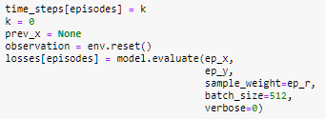

This segment of code is some bookkeeping and preparing the environment for the next episode of the game, as well as getting the loss from the model. The first line of this code saves the k value into the time_steps array. This is done to track the timesteps over the episodes, as well as giving a representation of how long it takes the model to achieve a certain score given. Once this value is saved, the k value is set back to zero so the timesteps can be tracked during the next.

The third line of this segment of code is clearing the previous observation frame of the game. Before prev_x is set to none, it is the last frame in the previous game of pong. We don’t want to use this frame in the difference of frame calculation, so it is cleared and then the difference of frame calculation uses an array of zeroes instead of the prev_x.

Because the game has already reached its score limit, or the max k value was reached, the game needs to be reset for a new episode. To do this, env.reset() is ran which clears the recreates a new episode of the pong game. This is set equal to the observation because when the environment is reset, it returns an image of the first frame of the game. Saving this as the observation means that the first frame is saved into the observation, and the episode can begin.

The last line of this code segment returns the loss value from the training and saves it into the losses array. To get the losses from the model in Keras, the evaluation method is used. This method returns the lost value and metrics values for the model. The arguments for this are like that of the fit method. The first argument is the input data, which is set to ep_x. The second argument is the target data, which must be the same type of data structure as the input data. For the target data, ep_y is used. Next, the sample weight is given as an argument and for this, the array of discounted and standardized rewards is used for the episode or ep_r. Next is the batch size which must be an integer, and the value of 512 is used to match the fit method. Lastly, the verbosity of the model is set, and in this case, it is set to silent zero, but it can also be set to one which is a progress bar.



This conditional statement for this segment of code acts as a dropout for when the artificial intelligence reaches an average of 19 wins, it stops training. This is done to attempt to stop the model from overfitting and crashing rewards. The conditional statement calculates the mean of the past 10 episodes using NumPy mean and indexing the reward_sums array from the maximum value from 0 to episodes-10 to episodes. Using the maximum function allows for the value to still be calculated before the episodes reach the value of 10. When this mean value is greater than or equal to 19, which means the artificial intelligence is winning 21 games and losing 2, the training loop is broken out of.

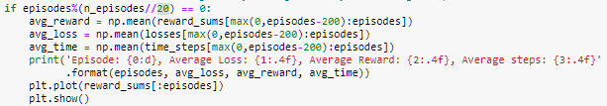

This is the last large segment of code in the training loop. This section of code deals with real-time progress tracking. This allows the user to see the progress that the artificial intelligence is making, based on its reward sums, loss, and average timesteps. First, a conditional statement is created. The conditional statement determines when and how frequently the live updates are given. When the episodes, the amount of episodes completed, modulus the total number of episodes divided by the number of updates wanted by the code using floor division, equals zero the live output will be shown. Modulus finds the remainder in the division, and floor division rounds the result to the nearest whole number. In my code, there are 20 live updates given through the training, and the number of episodes is 1000, so every 50 episodes and update is printed. To give an example, when episodes equal 50, and n_episodes equals 1000, making the floor division of 1000//20 come out to 50, the conditional will run because 50 modulus of 50 is zero.

When the conditional statement runs, the averages for rewards, losses, and time will be calculated. They are calculated using the NumPy function means. If the mean were to be calculated based on the rewards, loss, and time of the entire training, the results would be skewed right, meaning that the mean values would be more negative than they should be represented. To combat this, the range array is indexed, but instead of indexing the entire array, the array is indexed from the maximum value from 0, episodes-200. For the first 200 episodes, the mean will be calculated using all the values, after the first 200 episodes, the mean will be calculated based on the past 200 episodes. This means when we are on episode 600, the mean will be calculated from 400 to 600 in each of the arrays.

To get the average rewards, the avg_rewared variable is used and is set equal to the mean of the reward_sums array from the maximum value between 0 and episodes – 200 and episodes. To get the average loss, the avg_loss variable is used and is set equal to the mean of the losses array from the maximum value between 0 and episodes – 200 and episodes. To get the average time, the avg_time variable is used and is set equal to the mean of the time_steps array from the maximum value between 0 and episodes – 200 and episodes.

Once all of the average values have been calculated, they are then shown to the user using the print function. The print statement is print('Episode: {0:d}, Average Loss: {1:.4f}, Average Reward: {2:.4f}, Average steps: {3:.4f}' .format(episodes, avg_loss, avg_reward, avg_time)). To display the episode {0:d} is used to print out an integer value, for average loss {1:.4f} is used to display a float value to four decimal places, for average reward {2:.4f} is used to display a float value to four decimal places, and for average steps {3:.4f} is used to display a float value to four decimal places. To place the value inside this area, the format method is used, which places the variables inside of its parenthesis in order in the code. To determine the order, the first value inside of the {} is used. After the : inside the {}, the letter represents the data type. D represents an integer or a decimal, f represents afloat, and s represents a string. The .4 used selected the number of decimal places that will be displayed.

Lastly, under this print function, there will be a graph that displaces the rewards over time. This is done using the matplotlib.pyplot library plt.plot is used to create the plot, and the values that will be shown are the reward_sums array, which is displayed from the beginning to the current episode. Then plt.show is used to show the plot to the user. Below is what the output of this will look like.

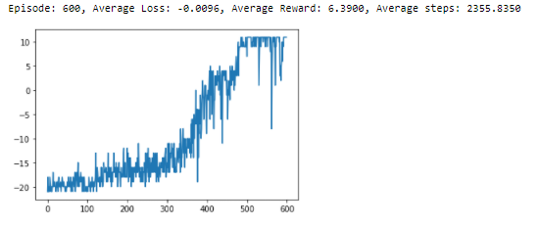

The last line of code in the training segment is closing the environment. This is only used if env.render() is uncommented at the beginning of the training and closes the pop-up box that is created while the model is training.



1. **Plotting The Results**

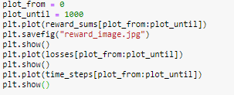

In this segment of code, the final rewards graph is shown and saved. The losses graph and the time steps graphs are also plotted in this segment. For each of these graphs, they are plotted between the plot_from and the plot_until variables, which can be changed to see different segments of the graphs. This is done to get a representation of the improvements from different segments of the learning. To start, the plot_from variable is set to 0, meaning that the graph will start from the first episode of learning. Next, the plot_until variable is set to 1000, which is the same as n_episodes. This is done to plot the entirety of the graphics to begin.

To plot these graphs, the mathplotlib function plot is used. The first figure that is plotted is the rewards_sums array. This is plotted from the index of plot_from to plot_until. This plot is then saved using the save fig function as reward_image.jpg. Then using the show function, the plot is shown inside of the jupyter notebook. Using the show function clears outputs the plot and deletes it from the memory.

Next, the losses are plotted. They are plotted using the same function and using the same range as the reward_sums. Lastly, the timesteps are plotted using the same range. Below is what the output of this segment of code looks like. These will look similar, but not the same between each different machine learning model that is created.

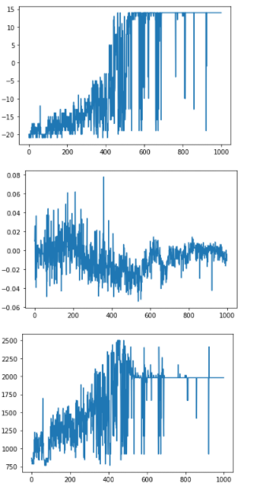

1. **Watch The Model Play**

In this segment of code, you get to see the artificial intelligence play the game of pong after it has completed all of its learning. The game is slowed down so that the game can be seen while it’s playing instead of it being incredibly fast while it is in training.

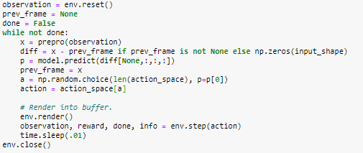

The first line of this code segment resets the environment so that the game that was being used in the training is cleared. This reset returns the first frame of the game which is then saved into the observation variable. Because this is the start of the game, the prev_frame is set to none because there is no previous frame. Next, the variable done is set to false, meaning the game is not done. The done variable will be changed to true once the match is over.

To play the game, a loop is created. The condition of this while loop is while not done, meaning when the game is not finished to loop will keep repeating. The first line of the loop is preparing the current frame of the game. The frame is prepared by being passed into the preprocessing function called prepro. This function reduces the size and complexity of the image so that it can be fed into artificial intelligence. This preprocessed image is then saved as the variable x.

The next line of code is how the difference of frames is calculated. This is done by subtracting the current frame, x, from the previous frame, prev_x. This line also has an if statement built into it that stops an error from occurring during the first frame of the episode. This is done by saying if prev_x is not none, then the difference of frames calculation is run, else np.zeroes(input_shape) is the result. This means that if prev_x is none, which it is set to before the training loop and after the end of each episode, an array of zeroes will be the image that is saved, and if it is not that first episode, then the difference of the frames is saved.

Next, artificial intelligence predicts the best move that can be made using the Keras method predict. This function takes an input of a NumPy array as an input and outputs a prediction. For the input samples, the current difference of frames is given as diff, and because the first convolution layer wants four dimensions, the array has a fourth dimension of none added using [None,:,:,:].

Once the prediction is gotten, the current frame is no longer needed, so the current preprocessed frame is saved as prev_frame or the previous frame. The next line of code uses random choice to stimulate the environment by using the NumPy function random choice. The first input that is given to this function is the length of the action space. This is in the random choice method which is what the random sample will be generated from. In this case, the length of action_space is two so the randomly generated sample will be generated from two. The second value that is given into the NumPy function is p which is the prediction value that is output by the model in the previous line. This will output a value of zero or one because of the length of the action_space. This would output the value of four or five. These are the actions of going up and down.

Next, the frame is rendered to the user so that the user can watch the game be played. To do this, the gym method of render is used in the environment. After the game has been rendered, the artificial intelligence will make its move using the env.step with the action being the action that was calculated earlier in the code. The output of completing a time step is the observation, reward, info, and done. The only two of these outputs that matter in this segment of code are the observation, which is the next frame of the game, and the done Boolean value, which will determine when the loop ends.

The last line of code inside this loop is what slows down the game so that the individual moves of the artificial intelligence can be seen. This is done using the python time library. With this library, the sleep function is used with the argument of 0.01. The sleep function puts the code to sleep for the number of seconds specified in the arguments, which in the case of this code is 0.01 seconds. This value can be changed if the game is wanted to be slowed down or sped up.

**Speed Comparison**

Through analyzing and running Karpathy’s code, there were definite gains in performance that were available. Karpathy’s code did not use a machine learning library such as Keras, TensorFlow, or PyTorch, and instead calculated the gradient descent in the code. This causes much slower learning because it is much less optimized than the libraries.

The main reason that Karpathy’s code is so much slower is because of the structure of the neural network that is used. For Karpathy’s neural network, it takes an array of 3600x1 values, which are gotten from the image preprocessing and the raveling those pixels into a one-dimensional array instead of keeping it as a two-dimensional array. The first layer that the inputs are connected to is the hidden layer of two hundred neurons, which are all directly connected to each of those 3600 input neurons. These two hundred neurons are directly connected to the output layer and use a sigmoid function to determine the final output. This structure is extremely inefficient as there are 720,400 adjustable parameters, which is calculated by multiplying the input neurons and then hidden state neurons plus the hidden state neurons times the number of outputs.

One factor that affects the change of the gradients that has an impact on the speed of the algorithm is the optimizer. Karpathy used the optimizer leaky rmsprop to update all the parameters. Through the test that I ran on my code, it was found that leaky rmsprop was not the most efficient optimizer to be using on the code. Another factor is that this optimizer is not fully optimized with its hyperparameters, but the Adam optimizer defaults to the most efficient hyperparameters for that algorithm.

Another significant impact on performance in Karpathy’s code is that the batch size is ten episodes. This means that the game of pong will play for ten episodes, and then use all the observations, actions, and rewards from those ten episodes to train. This means that there is a substantial number of variables in the array that are used to calculate the gradient in the new episode. Not only that, but it further increases the training speed because, within each batch, every single adjustable parameter is adjusted.

One choice that greatly affected the speed of the training that Karpathy made was the environment that he chose. In his code, he chose to create the “Pong-v0” environment which does not have frame skipping. Although this does not affect the accuracy of the final model, it will take much longer to train because every frame is being viewed. To improve the speed in my code, the environment was created as “PongDeterministic-v4.” I found that PongDeterministic-v4 worked the best for this model. The reason that it works the best is that it skips four frames every time. In the non-deterministic version of the game, a frameskip is sampled from two to five. The difference between PongDeterminstic-v4 and v0 is that with v0, there is a 25% chance that the previous action will be taken instead of the newly calculated action. The v4 version makes that probability 0, which I have found to make the model run more accurately.

Shown below are the results of 15000 episodes of Karpathy’s code being run. Running these 15000 episodes took about 72 hours and the result was an average episode reward of -12.5. This means that for each episode, the artificial intelligence was winning around 8.5 matches and losing 21. As seen from the graph, the learning in the code is very gradual, but it is extremely steady with its progress. At no point does artificial intelligence start losing a lot more than in its episodes around it.

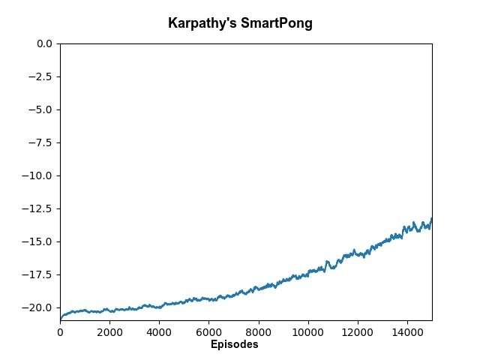

To get speed and accuracy gains over Karpathy’s code, I used Keras with a TensorFlow backend to do the machine learning instead of having everything hardcoded in the code. This allowed for more optimized algorithms to be used as well as different neural network structures. This allowed for a convolutional neural network to be used instead of a very basic neural network with one hidden layer to be used with ease. That is why Keras was used because of its ease of use and user-friendliness.

To combat the issue of having an extremely large amount of adjustable parameters, the structure of the neural network was changed. By using a convolutional neural network, which takes an image as input instead of a one-dimensional array, it is much more efficient. Instead of having one hidden layer with 200 nodes, the convolutional neural network uses filters that do not have as many adjustable parameters but are extremely efficient at picking out patterns in images. This allows my neural network to have 15490 adjustable parameters in one model and 3758 parameters in the other model. This allows for the values to be fine-tuned faster than Karpathy’s network because it only adjusts 15490 parameters or 3758 parameters instead of 720,400 parameters.

In Karpathy’s code, the gradient is updated by an algorithm that uses the rmsprop calculations. All of the hyperparameters are coded and were created by Karpathy, but this is not the most efficient approach. Using Keras, there is a wide variety of optimizers that can be used to change the gradient. The optimizer that was used in the final code was the optimizer Adam, which tended to be the most efficient. Using Keras to implement Adam, the hyperparameters are already finely tuned to be the most efficient. Other optimizers that were tested were degraded, adamax, and rmsprop. Rmsprop was the second most efficient optimizer after adam.

The largest impact on the speed and accuracy of the training that was made in my code was when the model was trained. In Karpathy’s code, after 10 episodes the training would happen. In my code, the model was trained after each episode. This allowed for it to train 10 times more over the same span of episodes, leading it to greater efficiency and quicker learning. To go along with updating every episode, not all of the trainable parameters are updated after each episode. Using the Keras fit function and the batch size argument, it can be tuned to a certain amount of parameter changes for each iteration, or each episode. Having not all of the values train at once also leads to exponentially faster learning because it takes less time to update fewer values, as well as not every value needs to be tweaked if it already has the desired accuracy. The model can then determine which parameters need to be changed the most based on the accuracy of each node.

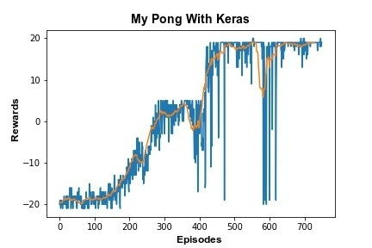

Comparing my graph of rewards over episodes versus Karpathy’s code, it can be seen how much more efficient using Keras is. In under 800 episodes, the mode that I made was able to train to a running average of positive 18, meaning that it won 21 games and lost three on average. To get to the average of Karpathy’s code, which was -12.5 over 15000 episodes, my model achieved it in less than 200 episodes. This is a 98.667% decrease in training speed. The main difference in the accuracies between the two codes is the steadiness of the model. Karpathy’s move’s steadily and predictably and never has a drastic drop, while mine moves more chaotically and has drastic drops in random episodes.

These random drops that are seen in my code are due to many factors, and without largely compromising on the speed and efficiency of the model, cannot be completely voided. When the model has a large uptick, which happens here at around 300 episodes and again at around 400 episodes, the artificial intelligence wins a lot more games because of its training, and it does not dip all of the ways back down because on the episode that it reaches that new max score, it learns how it got it from that episode. This can also work conversely, where the artificial intelligence will lose many games and then change to many of its values to compensate, which can cause a total crash of the model, causing it to lose many games. Shown below is an example of a crash that happened due to the training on the dropped game.

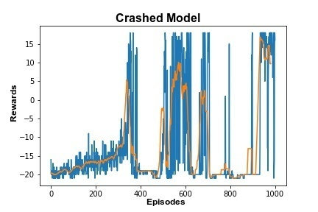

The graph shown above is using the same neural network structure and the same optimizer as the successful graph on the previous page. This model also ended up averaging 18 wins at the end, and after playing non-training games was able to reach 18 wins every time. This iteration of the model got there in a much different way. In less than 400 episodes, it had already achieved an 18 win game, but because it had such a spike, the training was not able to prepare for every game possible, which is why it had the crash. Why the model recovered and crash multiple times over the rest of the code until it finally settled at a score of 18 is unknown to me. Many tests of the training ended up crashing similarly, but more come was the model converging at a score that was less than 10. Most of the models would converge around a positive five and even with the training after each episode, were not able to achieve a higher score.

Even with the random crashing of the model, training my model to win more than lose will take a significantly less amount of time. Using 2500 timesteps, allowing the model to run through the entire set of 21 games instead of cutting it short, the model can train through 1000 episodes in under two hours. Karpathy’s model took 16000 episodes and three days to train to reach a score of -12.5. The risk of having a model that crashes or that doesn’t achieve a maximum score with my model is worth the tradeoff of the days of more training on Karpathy’s model to reach the same score.

**Optimization Graphs**

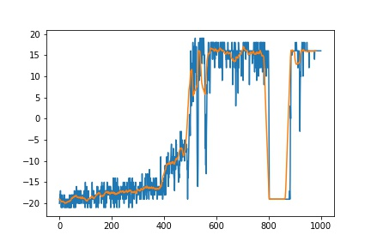

Adam using second model 2.5k timesteps, 1000 trials

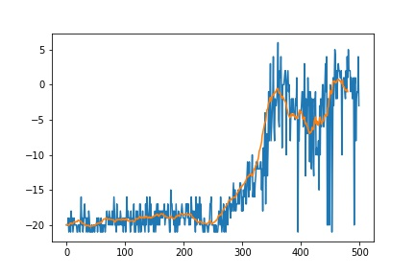

Adam using the second model, 1k timesteps 500 trails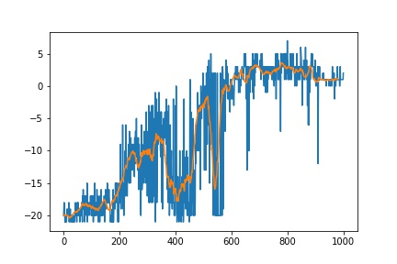

Adam using second model, 1.5k timesteps, 1000 trials

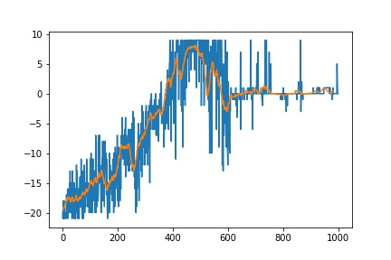

Adam using second model, 1k timesteps, 1000 trails

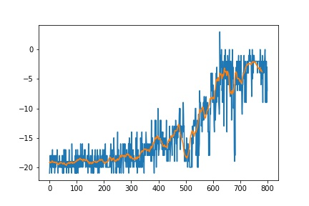

RMSProp second model using 1k timesteps, 800 trails

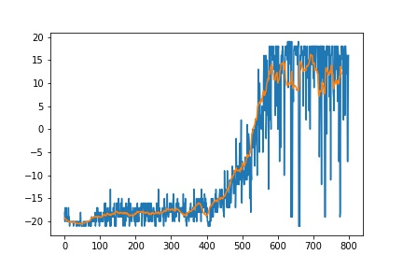

RMSProp second model using 2.5k timesteps, 800 trials

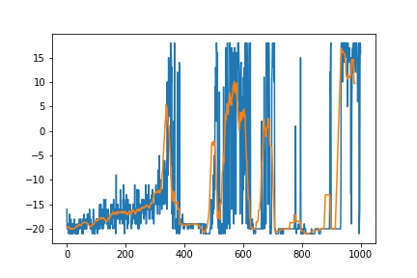

RMSProp second model using 3k timesteps, 1000 trials

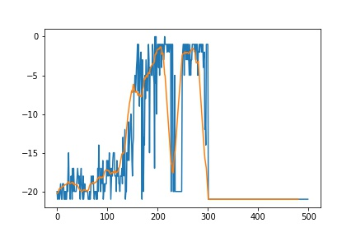

Nadam model 1, 2.5k timesteps, 500 trials

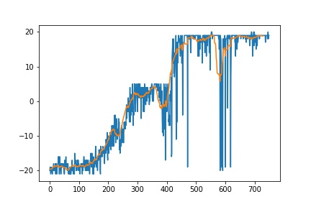

Adam First Model 2.5k timesteps, 750 trials, crashed after 750

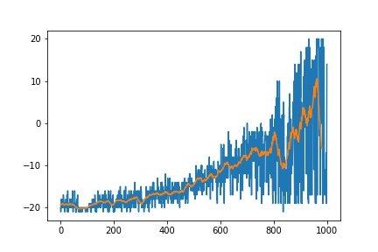

Adamax first model 2.5k timesteps, 1000 trials

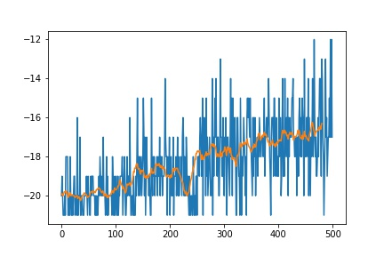

Adagrad first model, 2.5k timesteps, 500 episodes

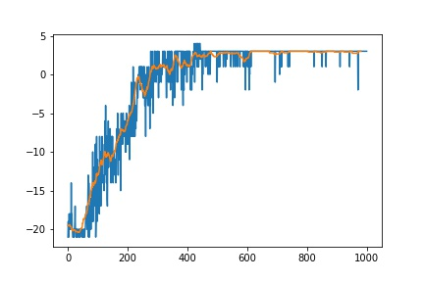

Adam first model, 1k timesteps, 100 episodes

**The Process to Create My Code**

Coming into this co-op, I had very limited knowledge of machine learning and the artificial intelligence field. The most that I had done was read some of the TensorFlow API and watch a handful of educational videos on the topic. To start to understand machine learning, I was given Andrev Karpathy’s SmartPong code and technical documentation that multiple previous co-ops had worked on. This technical documentation went over the core principles that were used in Karpathy’s code, as well as the theory behind them. Using this documentation along with the SmartPong code, I was able to achieve a basic understanding of how machine learning worked and the basic principles behind it.

Once I had those basic principles, I jumped right in to make my model, only to hit a brick wall. I knew the basic principles, but I did not fully understand them. This made it extremely difficult to make the code because I had no clue where to start. Once I hit this brick wall, I started researching TensorFlow, PyTorch, stable baselines, and Keras. I also started reading technical documents that have been published on the topic of using machine learning to play video games, specifically Atari games The most useful of these articles gave me the structure of one of the models that I used. Most of these technical documents were theoretical and covered the best model structures and the best model type to use in the Atari games, the two best being a dqn and a cnn.

After understanding the core principles and knowing the structure of the model I was going to create, I started writing code once again. I took the approach to solve a simpler problem first to understand how to create new code. In this process, I created a model using stable baselines to play the game cart pole, where a cart tries to perfectly balance a pole on top of it.

To create this simple model, I used a video tutorial made by the YouTuber Nicholas Renotte titled “Reinforcement Learning in 3 Hours | Full Course using Python.” In this three-hour-long course, stable baselines were used to create the neural network and play the game of cart pole. This model used PPO or Proximal Policy Optimization as the structure of the neural network, which is a policy gradient method. It also used MlpPolicies as the input, meaning that it did not take in damage as an input and only had one input. Training this model was as simple as using the stable baselines to learn to function and choosing the number of time-steps. The game of cart pole was able to be completed and get a perfect score every time after around 20,000 timesteps.

After using this video tutorial, I decided to change the environment with the same code to the pong environment, but it ran into many issues. The biggest issue was training time. Because the game of pong is much more complex, using the same method takes multiple minutes per episode, which would take weeks to fully train. Even with editing the code and changing the input type to a cnn to take the image as the input, it ran far too slow, and I did not leave it on long enough to accomplish any training. I decided to move on and take a different approach and change off stable baselines and focus more on PyTorch and Keras.

The next model that I created was using PyTorch. For this, I tried to use a cnn Deep Q Network. This model used temporal difference loss for its training. I never ended up being able to get this model to work just because of the complications of using a cnn and a dqn, as well as PyTorch not being the most user-friendly platform to use for beginners in the field of machine learning.

After this attempt, I switched over to TensorFlow and Keras and made what would be my final model for this project. I started by reading technical documentation to find the best neural network structure to use while still being simple., and I decided on a convolutional neural network or a cnn. Because the input to the neural network from the game of pong is an image, a convolutional neural network will work the best, and I decided to clear the completion of also using a deep q network even though it has a possible speed benefit.

In this iteration of the code, I wanted to keep some of the components that Karpathy had used in his approach and work on improving the neural network instead of the code. I also wanted to follow in the spirit of Karpathy to show that this is possible in a short amount of code. In the earlier iterations of my code, I had hundreds of lines of code, some of which were hard to comment on and just had to be there for the model to function. To start, I used the same code as Karpathy did for the discounting of the rewards and the image preprocessing. Using these allowed for a more exact comparison between my code and his code. The rewards are the way that reinforcement learning is taught, so using the same rewards system enable a comparison between the two code. One change that I made was I created the discounted reward standardization as a function, while Karpathy had it inside of his training loop. Also, preprocessing was the most efficient way to preprocess the image.

The largest improvement that I created over Karpathy’s code was the decision to use a convolutional neural network instead of only using fully connected layers. Because convolutions can detect certain properties from an image, they can be much more efficient. The convolutional neural network is also able to drastically decrease the number of trainable parameters that the model has because it is finely tuned for taking an image as input. In Karpathy’s code, the image is raveled, or unraveled to be into a one-dimensional array, and all of the values in that array are directly connected to the hidden layer of 200 neurons which creates over 700,000 trainable parameters. This is a large number compared to the maximum of 15,000 trainable parameters in my largest model.

Another change that I decided to make to Karpathy’s code was when the neural network trained. Karpathy trained the neural network after 10 episodes and changed all the trainable parameters. My approach was to train the neural network after each episode, but only train some of the parameters at a time, which ended up being 512 parameters. This allows the training speed to increase because there is less time needed to adjust the parameters, and it also led to a large performance gain over Karpathy’s mode.

If I could start this project over again, I would have completely skipped working in PyTorch because I could not get it working correctly with my model at the time, and if I had used TensorFlow before that I could have finished the code much sooner. Although stable baselines could never work with the pong code because of training speed limitations, learning how to create that code and use the gym Atari environment was a crucial step to creating the code for my final model. I also wish that I had tried to use GPU acceleration more than I did. I ran into many problems with GPU acceleration because the Cuda application would not properly install onto my desktop. If I had enabled the GPU acceleration, the training speed could have increased slightly. I am still working on getting GPU acceleration to work, but it is more of a hardware issue than a software issue.

**References**

|  |  |
| --- | --- |
| [1] | M. Rahtz, *TensorFlow-rl-pong: Pong AI trained using policy gradient-based reinforcement learning*. |
| [2] | F. Shaikh, “An introduction to implementing Neural Networks using TensorFlow,” *Analytics Vidhya*, 03-Oct-2016. [Online]. Available: https://medium.com/analytics-vidhya/an-introduction-to-implementing-neural-networks-using-tensorflow-4082c036d40c. |
| [3] | DeepAI, “Weight (Artificial Neural Network),” *Deepai.org*, 17-May-2019. [Online]. Available: https://deepai.org/machine-learning-glossary-and-terms/weight-artificial-neural-network. |
| [4] | S. Abeywardana, “Deep reinforcement learning,” *Towards Data Science*, 29-Jun-2019. [Online]. Available: https://towardsdatascience.com/deep-reinforcement-learning-pong-from-pixels-keras-version-bf8a0860689f. |
| [5] | J. Brownlee, “A gentle introduction to the rectified linear unit (ReLU),” *Machinelearningmastery.com*, 08-Jan-2019. [Online]. Available: https://machinelearningmastery.com/rectified-linear-activation-function-for-deep-learning-neural-networks. |
| [6] | *atari-py: A packaged and slightly-modified version of https://github.com/bbitmaster/ale_python_interface*. . |
| [7] | A. Khan, J. Feng, S. Liu, and M. Z. Asghar, “Optimal skipping rates: Training agents with fine-grained control using deep reinforcement learning,” *J. robot.*, vol. 2019, pp. 1–10, 2019. |
| [8] | “Python Release Python 3.7.0,” *Python.org*. [Online]. Available: https://www.python.org/downloads/release/python-370. |
| [9] | A. Rosebrock, “Keras Conv2D and convolutional layers,” *Pyimagesearch.com*, 31-Dec-2018. [Online]. Available: https://www.pyimagesearch.com/2018/12/31/keras-conv2d-and-convolutional-layers. |
| [10] | “Policy gradients tutorial (with ping pong),” 12-May-2019. [Online]. Available: https://www.youtube.com/watch?v=O81MJxghn-M. |
| [11] | M. Labs, “Everything you need to know about Neural Networks,” *Hackernoon.com*, 01-Nov-2017. [Online]. Available: https://hackernoon.com/everything-you-need-to-know-about-neural-networks-8988c3ee4491. |
| [12] | “Understanding the role of the discount factor in reinforcement learning,” *Stackexchange.com*. [Online]. Available: https://stats.stackexchange.com/questions/221402/understanding-the-role-of-the-discount-factor-in-reinforcement-learning. |
| [13] | A. Al-Masri, “How does back-propagation in artificial Neural Networks work?,” *Towards Data Science*, 29-Jan-2019. [Online]. Available: https://towardsdatascience.com/how-does-back-propagation-in-artificial-neural-networks-work-c7cad873ea7. |
| [14] | “What does the hidden layer in a neural network compute?,” *Stackexchange.com*. [Online]. Available: https://stats.stackexchange.com/questions/63152/what-does-the-hidden-layer-in-a-neural-network-compute. |
| [15] | DeepAI, “Hidden Layer,” *Deepai.org*, 17-May-2019. [Online]. Available: https://deepai.org/machine-learning-glossary-and-terms/hidden-layer-machine-learning. |
| [16] | “Gradient descent: An introduction to 1 of machine learning’s most popular algorithms,” *Builtin.com*. [Online]. Available: https://builtin.com/data-science/gradient-descent. |
| [17] | “But what is a neural network? | Chapter 1, Deep learning,” 05-Oct-2017. [Online]. Available: https://www.youtube.com/watch?v=aircAruvnKk. |
| [18] | “Gradient descent, how neural networks learn | Chapter 2, Deep learning,” 16-Oct-2017. [Online]. Available: https://www.youtube.com/watch?v=IHZwWFHWa-w. |
| [19] | “What is backpropagation really doing? | Chapter 3, Deep learning,” 03-Nov-2017. [Online]. Available: https://www.youtube.com/watch?v=Ilg3gGewQ5U. |
| [20] | “Backpropagation calculus | Chapter 4, Deep learning,” 03-Nov-2017. [Online]. Available: https://www.youtube.com/watch?v=tIeHLnjs5U8. |
| [21] | T. Wood, “Sigmoid Function,” *Deepai.org*, 27-Sep-2020. [Online]. Available: https://deepai.org/machine-learning-glossary-and-terms/sigmoid-function. |
| [22] | “Weights & Biases,” *Wandb.ai*. [Online]. Available: https://wandb.ai/ayush-thakur/dl-question-bank/reports/ReLU-vs-Sigmoid-Function-in-Deep-Neural-Networks-Why-ReLU-is-so-Prevalent--VmlldzoyMDk0MzI. |
| [23] | D. Gupta, “Activation functions,” *Analyticsvidhya.com*, 29-Jan-2020. [Online]. Available: https://www.analyticsvidhya.com/blog/2020/01/fundamentals-deep-learning-activation-functions-when-to-use-them/. |
| [24] | “Initializing neural networks,” *Deeplearning.ai*. [Online]. Available: https://www.deeplearning.ai/ai-notes/initialization/. |
| [25] | J. Brownlee, “Understand the impact of learning rate on neural network performance,” *Machinelearningmastery.com*, 24-Jan-2019. [Online]. Available: https://machinelearningmastery.com/understand-the-dynamics-of-learning-rate-on-deep-learning-neural-networks/. |
| [26] | “Python Lessons,” *Pylessons.com*. [Online]. Available: https://pylessons.com/DQN-PONG/. |
| [27] | M. K. Turkcan, *keras_pong.py at master · mkturkcan/Keras-Pong*. . |
| [28] | *ppo_cartpole.py at master · keras-team/keras-io*. . |
| [29] | Keras Team, “Models API,” *Keras.io*. [Online]. Available: https://keras.io/api/models/. |
| [30] | Keras Team, “Keras layers API,” *Keras.io*. [Online]. Available: https://keras.io/api/layers/. |
| [31] | “Module: tf,” *Tensorflow.org*. [Online]. Available: https://www.tensorflow.org/api_docs/python/tf. |
| [32] | “Deep reinforcement learning for Atari games python tutorial | AI plays space invaders,” 30-Dec-2020. [Online]. Available: https://www.youtube.com/watch?v=hCeJeq8U0lo. |
| [33] | “TensorFlow Tutorial 2 - Tensor Basics,” 09-Aug-2020. [Online]. Available: https://www.youtube.com/watch?v=HPjBY1H-U4U. |
| [34] | “Reinforcement Learning in TensorFlow with TF-Agents (TF Dev Summit ’19),” 06-Mar-2019. [Online]. Available: https://www.youtube.com/watch?v=-TTziY7EmUA. |
| [35] | “Using keras and deep Q-network to play FlappyBird,” *Github.io*. [Online]. Available: https://yanpanlau.github.io/2016/07/10/FlappyBird-Keras.html. |
| [36] | D. Parmelee, “Getting an AI to play atari Pong, with deep reinforcement learning,” *Towards Data Science*, 26-Jan-2021. [Online]. Available: https://towardsdatascience.com/getting-an-ai-to-play-atari-pong-with-deep-reinforcement-learning-47b0c56e78ae. |
| [37] | Keras Team, “Conv2D layer,” *Keras.io*. [Online]. Available: https://keras.io/api/layers/convolution_layers/convolution2d/. |
| [38] | J. Brownlee, “A gentle introduction to padding and stride for convolutional neural networks,” *Machinelearningmastery.com*, 18-Apr-2019. [Online]. Available: https://machinelearningmastery.com/padding-and-stride-for-convolutional-neural-networks/. |
| [39] | G. Surma, “Atari - solving games with AI 🤖 (part 1: Reinforcement Learning),” *Medium*, 02-Oct-2018. [Online]. Available: https://gsurma.medium.com/atari-reinforcement-learning-in-depth-part-1-ddqn-ceaa762a546f. |
| [40] | D. Patel, H. Hazan, D. J. Saunders, H. T. Siegelmann, and R. Kozma, “Improved robustness of reinforcement learning policies upon conversion to spiking neuronal network platforms applied to Atari Breakout game,” *Neural Netw.*, vol. 120, pp. 108–115, 2019. |
| [41] | I.-A. Hosu and T. Rebedea, “Playing Atari games with deep reinforcement learning and human checkpoint replay,” *arXiv [cs.AI]*, 2016. |
| [42] | Ł. Kaiser *et al.*, “Model based reinforcement learning for Atari,” *Arxiv.org*. [Online]. Available: http://arxiv.org/abs/1903.00374v4. |
| [43] | O. Vedpathak, “Playing Pong using Reinforcement Learning - towards data science,” *Towards Data Science*, 09-Jan-2019. [Online]. Available: https://towardsdatascience.com/intro-to-reinforcement-learning-pong-92a94aa0f84d. |
| [44] | IBM Cloud Education, “What is unsupervised learning?,” *Ibm.com*. [Online]. Available: https://www.ibm.com/cloud/learn/unsupervised-learning. |
| [45] | J. Jeong, “The most intuitive and easiest guide for convolutional neural network,” *Towards Data Science*, 24-Jan-2019. [Online]. Available: https://towardsdatascience.com/the-most-intuitive-and-easiest-guide-for-convolutional-neural-network-3607be47480. |
| [46] | S. Sharma, “Activation functions in neural networks - towards data science,” *Towards Data Science*, 06-Sep-2017. [Online]. Available: https://towardsdatascience.com/activation-functions-neural-networks-1cbd9f8d91d6. |
| [47] | P. Ganesh, “Types of convolution kernels : Simplified,” *Towards Data Science*, 18-Oct-2019. [Online]. Available: https://towardsdatascience.com/types-of-convolution-kernels-simplified-f040cb307c37. |
| [48] | Musstafa, “Optimizers in Deep Learning - MLearning.ai - Medium,” *MLearning.ai*, 27-Mar-2021. [Online]. Available: https://medium.com/mlearning-ai/optimizers-in-deep-learning-7bf81fed78a0. |